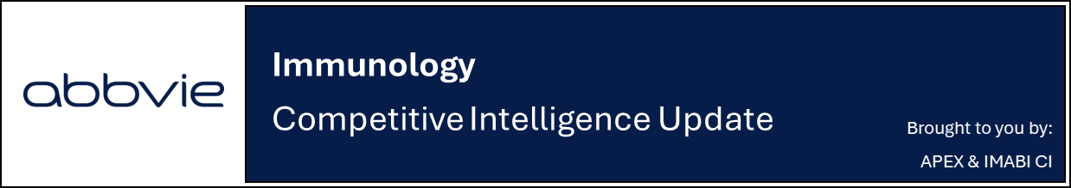

JNJ rolls out patient and HCP websites to support ICOTYDE’s launch

Company: JNJ  Drug: Icotyde (icotrokinra, oral IL-23R antagonist) | Date: March 20, 2026  Source(s): Icotyde Patient Website, Icotyde HCP Website

What happened:
- Following the FDA approval of ICOTYDE for the treatment of adults and adolescents aged 12+ years with moderate-to-severe plaque psoriasis on March 18, 2026, the patient and HCP websites for ICOTYDE are now fully activated
- Across both websites, the messaging appears focused on establishing ICOTYDE as a differentiated oral option through a combination of safety, skin clearance, once-daily dosing, and support program messaging
- The brand narrative is centered on safety which leads efficacy across navigation bars
  - Highlights ‘No reports of new or reactivated latent TB infections to date’ called out in their safety ‘no’ section
- JNJ is not making any superiority claims and H2H efficacy comparison is not prominent; the active comparator’s name is not mentioned on the patient website
  - There is presentation of mean PASI (89% at W24) for the first time
  - Long-term efficacy only shown for high impact areas (scalp, genital, hand/foot at W52); No 1-year claims in patient website
- For HCPs, ICOTYDE is framed as a first oral therapy that combines novel science with the simplicity of once-daily dosing to stand out in the PsO landscape
- For patients, ICOTYDE is positioned as “A new kind of treatment in a once-daily pill,” using unicorn imagery to signal its novelty

Impact (CI PoV): HIGH
- The rapid rollout of ICOTYDE patient and HCP websites (within two days of approval) underscores JNJ’s strong launch preparedness and aggressive strategy to engage both target patients and clinicians

Why it matters (CI Insights in blue italics):
- This early digital activation is important, as HCP websites may help shape prescribing behavior through clinical education, efficacy / safety data, and treatment positioning
- Patient websites will help drive awareness and facilitate discussions with physicians, supporting early uptake and adoption
- The website provides an early read on the claims being emphasized at launch
  - Safety appears to be featured prominently across both audiences, alongside skin clearance and once-daily oral convenience
  - Comparative and longer-term efficacy messaging appear to be used more selectively, with stronger emphasis placed on core clearance outcomes and practical treatment attributes
Tell me more:
- ICOTYDE websites use a unicorn to symbolize the novelty of the therapy (the first oral IL-23 inhibitor), which delivers a combination of convenience, efficacy, and safety
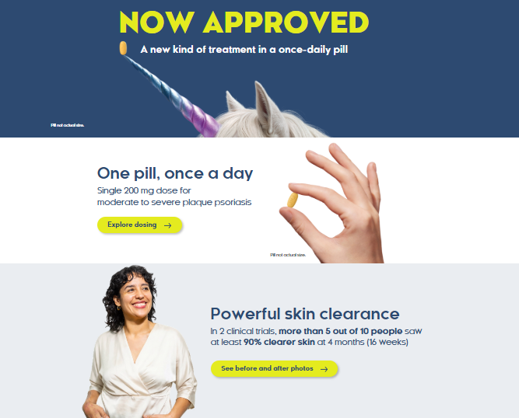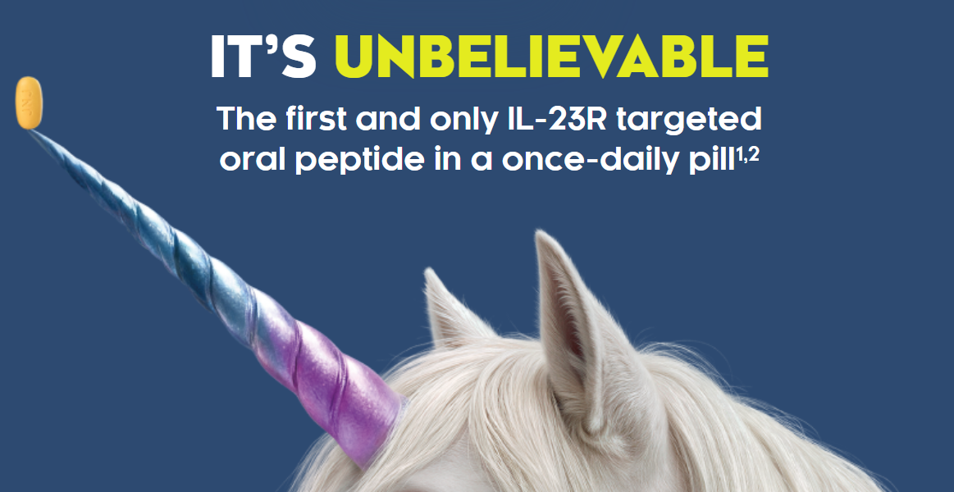

- About ICOTYDE and MOA:
  - The websites position ICOTYDE as a differentiated oral IL-23R targeted therapy, with repeated emphasis on its novel profile as a once-daily oral peptide
    - HCP messaging includes “IT’S UNBELIEVABLE. The first and only IL-23R targeted oral peptide in a once-daily pill” and “BELIEVE IN ICOTYDE AS YOUR FIRST-CHOICE SYSTEMIC THERAPY”
  - The HCP website also has a video describing the MoA
    - MoA messaging includes “ICOTYDE precisely blocks the IL-23 pathway by binding to the IL-23 receptor that is predominantly expressed in inflamed tissue”
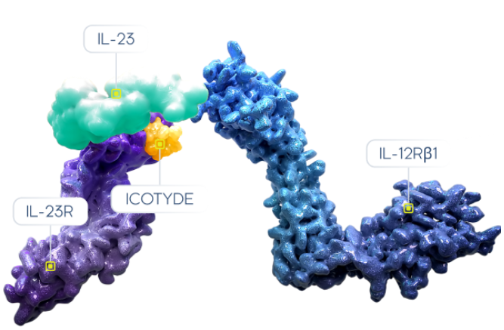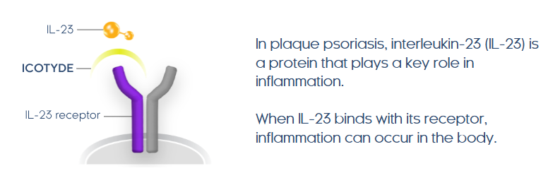
- Results:
  - While the HCP website offers details into the ICONIC program (ICONIC-LEAD, ICONIC-TOTAL and ICONIC-ADVANCE 1 & 2) covering the trial design and results, the patient website provides a more simplified overview of efficacy and study design
  - Across both websites, the messaging centers on “clearer skin” with ICOTYDE
    - HCP messaging includes “POWERFUL SKIN CLEARANCE WITH ICOTYDE”
    - Core efficacy claims include “MOST PATIENTS ACHIEVED CLEARER SKIN WITH ICOTYDE vs PLACEBO” and “COMPLETELY CLEAR SKIN ~1 IN 2 PATIENTS AT WEEK 24”
    - The HCP website also highlights “CLEARER SKIN WITH ICOTYDE”, with 89% mean PASI improvement at Week 24 and 42% at Week 4
  - Results from ICONIC-TOTAL are supported through messaging on “clearer skin in hard-to-treat areas” and “significant improvement in itch symptoms”
    - HCP materials include scalp, genital, and hand / foot psoriasis outcomes, as well as itch improvement in high-impact sites
    - The HCP website also states “49% of patients had completely clear skin at Week 16 (ss-IGA 0)”
  - The HCP website includes a dedicated section on adolescent patients, highlighting skin clearance and selected Week 24 (75% IGA 0, 64% PASI 100) and Week 52 results (82% IGA 0/1, 86% PASI 90, 95% PASI 75)
  - Comparative messaging is used selectively across both websites
    - The HCP website includes “MOST PATIENTS ACHIEVED CLEARER SKIN WITH ICOTYDE vs ACTIVE COMPARATOR AND PLACEBO” but does not state explicit superiority language or mention deucravacitinib
    - The patient website simply claims that “2x as many people had completely clear skin with ICOTYDE compared to another psoriasis pill”
  - Longer-term efficacy messaging appears more limited in patient-facing materials
    - Selected Week 52 results are included on the HCP website, particularly in adolescents and high-impact areas
    - Broader 1-year efficacy does not appear to be a major focus of the patient website
  - Before and after photos are included in both websites

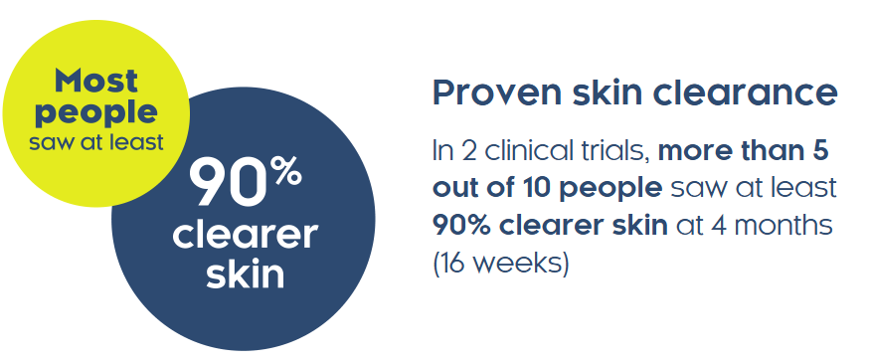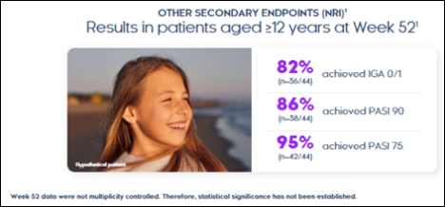
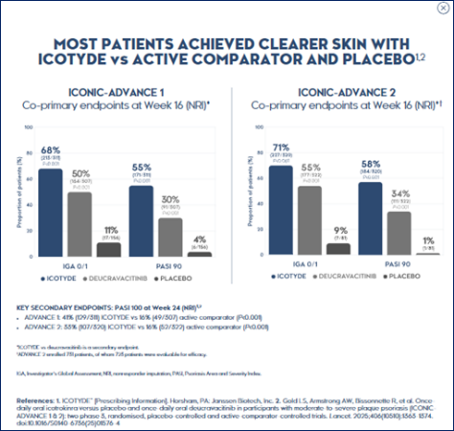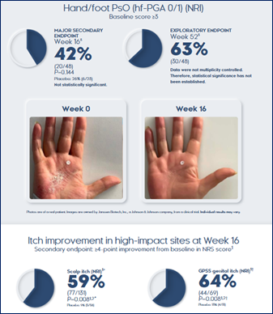

- Safety:
  - Safety is featured prominently across both websites messaging “Proven Safety Profile Across 4 phase 3 trials with 2300+ patients”
  - The HCP website also includes specific “no” language, including “no reports of new or reactivated latent TB infections to date”

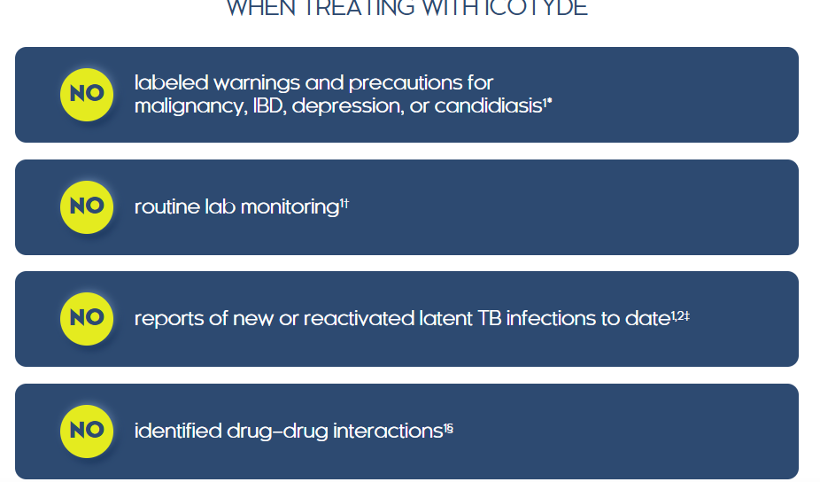
- Taking ICOTYDE:
  - The websites emphasize the convenience of a once-daily pill, including the dosing message “One Pill, Once a Day”
  - Benefits for patients and HCPs are respectively highlighted, with alternative administration also mentioned for patients who have difficulty swallowing pills
  - The patient website also includes practical administration guidance through “Wake + Take”, instructing patients to take ICOTYDE with water on an empty stomach upon waking-up and at least 30 minutes before eating

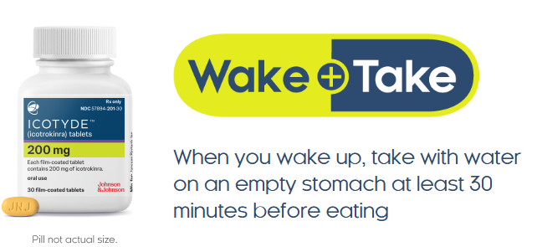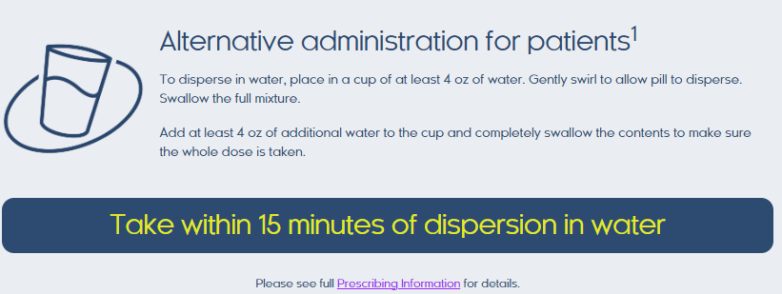
- Resources:
  - Patient website:
    - A patient brochure, Doctor Discussion Guide, and ICOTYDE withMe materials are available to support treatment education and discussion with physicians
    - ICOTYDE withMe is positioned as a free support program offering prescription and cost support, patient portal access, and a dedicated Nurse Guide (seamless treatment experience)
  - HCP website:
    - The website provides HCP tools including provider portal access, benefits verification, prior authorization support, and affordability programs to streamline prescribing
    - Additional tools include nurse assistance, adherence resources, and educational materials
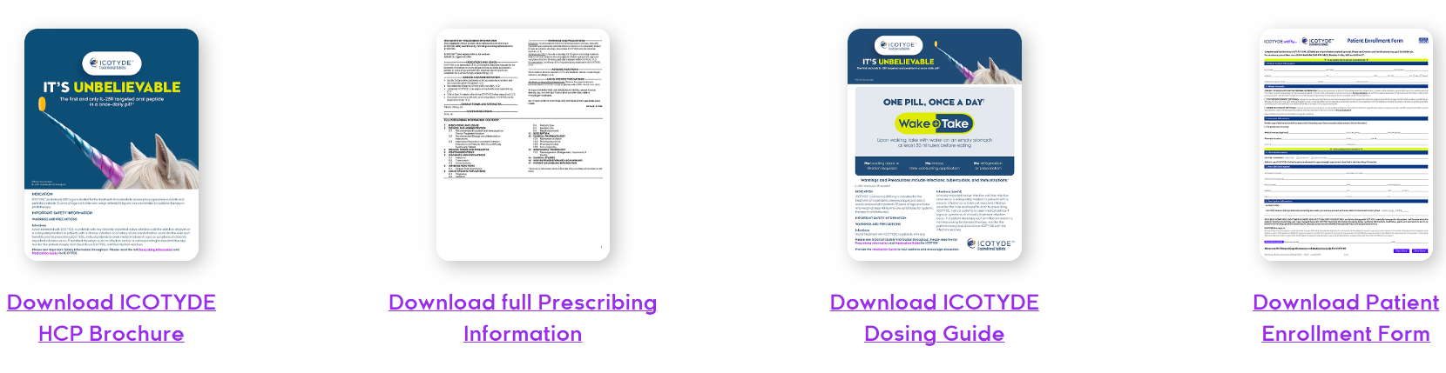

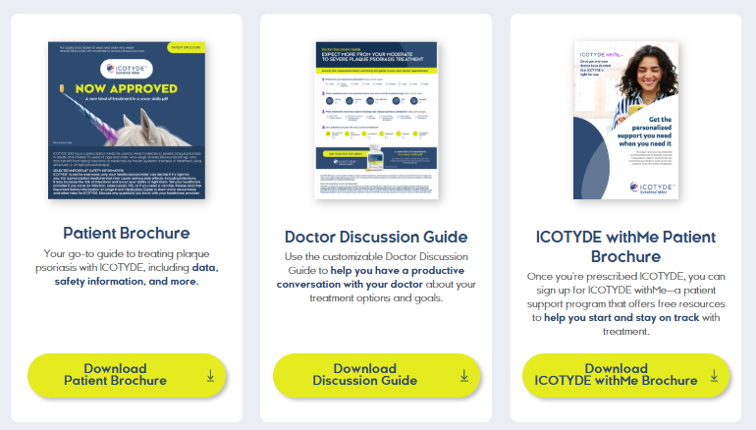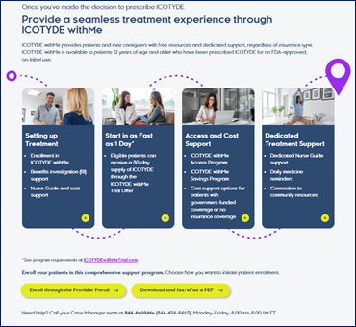

For questions, please reach out to:
 | Dermatology | Rheumatology | Gastroenterology
APEX (US/PCS) | Chanda Bhat | Bethany Christmann | Luke Versten
IMABI (International/ Affiliates) | Priti Anand | Irene Knorn | Priti Anand

Invite your colleagues to inVision | Manage Email Preferences | Unsubscribe

This document/email contains competitive intelligence collected via an approved competitive intelligence supplier working on behalf of AbbVie. We collect competitive intelligence consistent with industry standards and AbbVie policy. Not for field distribution. Please reach out to APEX/IMABI, Legal, or OEC teams with any questions.

